**SEGMENTATION OF BONE LESIONS ON PET/CT IMAGES USING THRESHOLDING AND REGION BASED TECHNIQUES: A COMPARITIVE STUDY**

*A Graduate Project Report submitted to Manipal University in partial fulfilment of the requirement for the award of the degree of*

**BACHELOR OF TECHNOLOGY**

**In**

**Electronics and Communication Engineering**

*Submitted by*

**Sree Pranavi Kanduri Parth Sehgal**

120907138 120907626

*Under the guidance of*

**Mr. Suhas M.V.**

Assistant Professor  
Department of Electronics and Communication

**MAY 2016**

**DEPARTMENT OF ELECTRONICS AND COMMUNICATION ENGINEERING**

**MANIPAL INSTITUTE OF TECHNOLOGY**

(A Constituent College of Manipal University)

MANIPAL – 576 104 (KARNATAKA), INDIA

**MAY 2016**

**DEPARTMENT OF ELECTRONICS AND COMMUNICATION ENGINEERING**

**MANIPAL INSTITUTE OF TECHNOLOGY**

(A Constituent College of Manipal University)

MANIPAL – 576 104 (KARNATAKA), INDIA

Manipal

11/05/16

**CERTIFICATE**

This is to certify that the project titled **SEGMENTATION OF BONE LESIONS ON PET/CT IMAGES USING THRESHOLDING AND REGION GROWING TECHNIQUES:A COMPARITIVE STUDY** is a record of the bonafide work done by **SREE PRANAVI KANDURI** (*Reg. No. 120907138*) and **PARTH SEHGAL** (*Reg. No. 120907626*)submitted in partial fulfilment of the requirements for the award of the Degree of Bachelor of Engineering (BE) in **ELECTRONICS AND COMMUNICATION ENGINEERING** of Manipal Institute of Technology Manipal, Karnataka, (A Constituent College of Manipal University), during the academic year 2015-2016.

|  |  |
| --- | --- |
| **Mr. Suhas M.V.**  *Project Guide* | **Dr. Somashekhar Bhat**  *HOD, E & C.*  *M.I.T, MANIPAL* |

**ACKNOWLEDGMENTS**

In this report, we have summarized our 4 month project titled SEGMENTATION OF BONE LESIONS ON PET/CT IMAGES USING THRESHOLDING AND REGION GROWING TECHNIQUES: A COMPARITIVE STUDY. We would like to take this opportunity to express our special thanks to our Project Guide and former teacher Suhas M.V. , Assistant Professor, Department of Electronics and Communication for clarifying all our doubts, guiding us and correcting us when needed, with a lot of attention and care.

With deep sense of gratitude we would like to acknowledge the encouragement and guidance from my Department. This project work has been a wonderful learning experience. It has surely helped us improve our technical skills. It has given us a much better understanding of the subject and knowing its practical applications.

**ABSTRACT**

Bone Metastases is caused by the tumour cells in the primary site (source) which break away into circulation to interact with the bone micro environment. Spinal metastasis is the third most common metastasis seen in cancer patients. The need for finding the exact location of the lesions is very important for the appropriate treatment. If the boundaries detected are smaller than the actual size of the tumor then some of the tumor cells are likely to be neglected which can cause further increase in their growth. On the other hand, if the boundary detected is larger than the actual size, then it leads to treatment which harms the healthier cells. Our objective is to find the exact boundary of the tumor using various segmentation techniques.

The project is carried out with the following two methods, Threshold based:Fundamentally, it is converting a color or grayscale image to binary image where each pixel is assigned a threshold value (T). Here, we are using this to locate lesions which are our area of interest, from the background. Different types of thresholding Global, Iterative and adaptive. For intensity based segmentation the proposed method here is adaptive thresholding. RegionGrowing**:** It is a method that incorporates spatial information in the image along with the intensity information and is thus more advantageous to histogram based methods. The algorithm starts at a user defined seed and based on the mean and standard deviation of the intensities within the local seed region connected pixels are either included or excluded in the segmentation results. A second input, a homogeneity metric, is used to decide how different a new pixel can be from the statistics of the region already selected and can still be included in the segmentation. This process is repeated until the entire region of interest has been dissected or the segmented region does not change.

Finally, metrics such as Dice similarity coefficient, Hausdorff distance, Jaccard’s similarity coefficient are used for comparing segmented images with the manually constructed ground truth. This helps us evaluate accuracy of our results. These algorithms to verify are applied on considerable number of PET/CT images and their average is found respectively. This gives us an understanding on which technique gives us a better result.

We observe that the segmented results much faster than manual segmentation and more reliable. The above project is helpful in providing a semi-automatic mechanism for image segmentation successfully. Tools used are Matlab, Image J, RadiAnt.

**LIST OF TABLES**

|  |  |  |
| --- | --- | --- |
| **Table No** | **Table Title** | **Page No** |
| 4.1 | Similarity Coefficient of CT images using Region Growing technique. | 16 |
| 4.2 | Similarity Coefficient of CT images using Adaptive Thresholding technique. | 16 |
| 4.3 | Similarity Coefficient of PET images using Region Growing technique. | 21 |
| 4.4 | Similarity Coefficient of PET images using Adaptive Thresholding technique. | 21 |

**LIST OF FIGURES**

|  |  |  |
| --- | --- | --- |
| **Figure No** | **Figure Title** | **Page No** |
| 4.1 | (Clockwise top left to bottom left) CT Image 1 of spinal Thoracic (cross section view) Source: Manipal Hospital Bangalore, Segmented image using Region growing, Segmented image using Thresholding, Ground truth which is manually segmented. | 10 |
| 4.2 | (Clockwise top left to bottom left) CT Image 2 of spinal Lumbar (cross section view) Source: Manipal Hospital Bangalore, Segmented image using Region growing, Segmented image using Thresholding, Ground truth which is manually segmented. | 11 |
| 4.3 | (Clockwise top left to bottom left) CT Image 3 of spinal Lumbar (cross section view) Source: Manipal Hospital Bangalore, Segmented image using Region growing, Segmented image using Thresholding, Ground truth which is manually segmented. | 12 |
| 4.4 | (Clockwise top left to bottom left) CT Image 4 of spinal Lumbar (cross section view) Source: Manipal Hospital Bangalore, Segmented image using Region growing, Segmented image using Thresholding, Ground truth which is manually segmented. | 13 |
| 4.5 | (Clockwise top left to bottom left) CT Image 5 of spinal Lumbar (cross section view) Source: Manipal Hospital Bangalore, Segmented image using Region growing, Segmented image using Thresholding, Ground truth which is manually segmented. | 14 |
| 4.6 | (Clockwise top left to bottom left) CT Image 6 of spinal Lumbar (cross section view) Source: Manipal Hospital Bangalore, Segmented image using Region growing, Segmented image using Thresholding, Ground truth which is manually segmented. | 16 |
| 4.7 | Graphical analysis of similarity coefficient | 17 |
| 4.8 | Graphical analysis of mean of DSC and HD | 18 |
| 4.9 | (Clockwise top left to bottom left) PET Image 1 of spinal Lumbar (cross section view) Source: Manipal Hospital Bangalore, Segmented image using Region growing, Segmented image using Thresholding, Ground truth which is manually segmented. | 19 |
| 4.10 | (Clockwise top left to bottom left) PET Image 2 of spinal Thoracic (cross section view) Source: Manipal Hospital Bangalore, Segmented image using Region growing, Segmented image using Thresholding, Ground truth which is manually segmented. | 20 |
| 4.11 | (Clockwise top left to bottom left) PETT Image 3 of spinal Lumbar (cross section view) Source: Manipal Hospital Bangalore, Segmented image using Region growing, Segmented image using Thresholding, Ground truth which is manually segmented. | 20 |
| 4.12 | (Clockwise top left to bottom left) CT Image 4 of spinal Lumbar (cross section view) Source: Manipal Hospital Bangalore, Segmented image using Region growing, Segmented image using Thresholding, Ground truth which is manually segmented. | 21 |
| 4.13 | Graphical analysis of similarity coefficient | 22 |
| 4.14 | Graphical analysis of mean of DSC and HD | 23 |

|  |  |  |  |  |  |
| --- | --- | --- | --- | --- | --- |
| **Contents** | | | | | |
|  | | | | | Page No |
| Acknowledgement | | | |  | i |
| Abstract | | | |  | ii |
| List Of Figures | | | |  | iii |
| List Of Tables | | | |  | vi |
|  | | | | | |
| **Chapter 1** | | | **INTRODUCTION** | |  |
|  | **1.1** | Introduction | | | 1 |
|  | **1.2** | Motivation | | | 1 |
|  | **1.3** | Objective | | | 1 |
|  | **1.4** | Target Specification | | | 2 |
|  | **1.5** | Project Schedule | | | 2 |
|  | | | | | |
| **Chapter 2** | | | BACKGROUND THEORY | |  |
|  | **2.1** | Introduction | | | 3 |
|  | **2.2** | Segmentation using Thresholding Technique | | | 3 |
|  | **2.3** | Segmentation using Region Growing Technique | | | 4 |
|  | **2.4** | Similarity Coefficients | | | 4 |
|  | | | | | |
| **Chapter 3** | | | **METHODOLOGY** | |  |
|  | **3.1** | Thresholding | | | 6 |
|  | **3.2** | Region Growing | | | 8 |
|  | | | | | |
| **Chapter 4** | | | **RESULT ANALYSIS** | |  |
|  | **4.1** | CT Images | | | 10 |
|  | **4.2** | PET Images | | | 17 |
|  | **4.3** | Comparing Results with three metrics | | | 24 |
|  | | | | | |
| **Chapter 5** | | | **CONCLUSION AND FUTURE SCOPE** | |  |
|  | **5.1** | Work Conclusion | | | 25 |
|  | **5.2** | Future Scope of Work | | | 25 |
|  | | | | | |
| **REFERENCES** | | | | | **26** |
| **ANNEXURES (OPTIONAL)** | | | | | **30** |
| **PROJECT DETAILS** | | | | | **37** |

**CHAPTER 1**

**INTRODUCTION**

*1.1 Introduction*

Bone Metastases is caused by the tumour cells in the primary site (source) which break away into circulation to interact with the bone micro environment. The bone provides favourable surroundings for the formation of tumours. There are three types of bone Metastases: Osteolytic, Osteoblastic and a mixture of the both. The need for proper detection of bone metastases is of utmost important as it is cause of death in majority of the cases. We have worked on two different techniques to segment the CT/PET images and prepared a comparative analysis. These semi-automatic segmentation techniques help to improve efficiency of the entire process.

*1.2 Motivation*

Patients with bone lesions such as bone metastasis suffer from a lot of pain, fractures and also immobility. PET/CT imaging enables localization of these bone lesions. Manual segmentation of bone metastasis is very tedious and not reliable. Segmentation techniques depend on the image and it can be very complex process. The challenges we face because of PET/CT images is that there is difference in illumination over the image and it has low resolution. With basic segmentation techniques, we do not acquire every detail we intend to. Hence, we go for techniques which can handle variation in illumination. In this project, comparison between thresholding based techniques and region based techniques can be achieved.

*1.3 Objectives*

* Study of various Thresholding techniques for segmentation of PET/CT images.
* Study of Region based methods for segmentation of PET/CT images.
* Comparision of Thresholding and region based techniques.

*1.4 Importance of end results*

The end results are the segmented images of the region having tumours. The results being accurate, it can save one’s life. These images can be further analysed for detection and diagnosis of bone metastases. The segmentation methods applied here are semi automated and are much quicker and reliable as compared to the manual segmentation method. The Dice similarity coefficient is a coefficient value obtained to measure the accuracy of result as compared to ground truth.

*1.5 Project Schedule*

|  |  |
| --- | --- |
| *January 2015* | * Background research on bone metastasis. * Study on various imaging modalities used for detection of spinal metastasis. * Basics of Image Segmentation. * Detailed study on Segmentation techniques on PET/CT images. |
| *February 2015* | * Thorough research on thresholding techniques for segmentation. * Basic implementation of these techniques on simple images. * Implementation on PET/CT images and comparing their results. |
| *March 2015* | * Research on region based techniques i.e, region growing and random walk algorithm. * Basic implementation on simple images. * Implementation on PET/CT and comparing their results. |
| *April 2015* | * Comparing the best results of thresholding and region based methods and choosing the appropriate technique for final implementation. |
| *May 2015* | * Documentation |

**CHAPTER 2**

**BACKGROUND THEORY**

*2.1 Introduction*

The field of biomedical imaging plays a significant role in diagnosing the disease state especially in oncology. Various imaging diagnostics are being used for this purpose, such as US (Ultra sound), MRI (Magnetic resonance imaging), PET (positron emission tomography), CT (computed tomography). Here in our project, we’ll be working on PET/CT images. Where, PET deals with functional imaging i.e., measurement of blood flow, chemical composition etc, where as CT deal with structural anatomical imaging which is the image of a slice when an X-ray beam was focused. Small malignancies are neglected in CT image; tiny tumours are detected and allows tumour to be shown brightly.

Using the above mentioned imaging modalities we are going to analyse the localization of bone lesions. In the subsequent sections, different segmentation techniques will be explained.

*2.2 Segmentation using Thresholding technique*

It is the simplest way of separating the object from background. Fundamentally, it is converting a color or grayscale image to binary image where each pixel is assigned a threshold value (T). Here, we are using this to locate lesions which are our area of interest, from the background.

Thresholding can be categorized based on utilization such as histogram shape-based methods, measurement space clustering, histogram entropy, object attribution, spatial information and local characteristics.

*Global Thresholding*: A certain threshold value if chosen which is fixed throughout the image. The pixels above this threshold is 1 and below is 0 or vic-viz.

*Iterative Thresholding:* Choose a suitable initial threshold value and apply it to a certain image. The two regions obtained in the result are R1 and R2. The average gray values of each of the regions are found. The mean of the obtained values is set as the new threshold and this is iterated for 2-4 times.

*Adaptive Thresholding:*This is one of the widely used methods for intensity based segmentations. For every pixel belonging to the image, a threshold has to be calculated. While dealing with PET/CT scans with variable illumination over the image, normal thresholding will neglect certain minute details which might be useful. Using adaptive thresholding for images with large difference in intensities will produce better results. The basic concept that when a colour image or a gray scale image is inputted, it outputs a binary image remains the same. Each pixel value is set based on local statistics such as mean, standard deviation etc.

*2.3 Region based Segmentation technique*

It is a method that incorporates spatial information in the image along with the intensity information and is thus more advantageous to histogram based methods.

The algorithm starts at a user defined seed and based on the mean and standard deviation of the intensities with in the local seed region connected pixels are either included or excluded in the segmentation results. A second input, a homogeneity metric, is used to decide how different a new pixel can be from the statistics of the region already selected and can still be included in the segmentation. This process is repeated until the entire region of interest has been dissected or the segmented region does not change.

The segmented region is thus separated into foreground and background for our purpose.

*2.4 Similarity Coefficients*

*Dice Similarity Coefficient*

Two images are compared with each other to check the similarity between them. The results obtained are rather empirical than theoretical. This shows the overlap of one image with the other. The correlation between them is found out. DSC (Dice similarity co-efficient), this method is used to study the accuracy of the above mentioned techniques. The co-efficient is an overlap value insensitive to the volumetric parameter.

*Advantage of DSC:*

1. It is a simple method and can be effectively used to calculate the similarity of two images.
2. It is extremely helpful in medical image processing as it is used to measure the quality and relevance of segmentation output results by comparing them with the ground truth.
3. It is not affected much by noise.

*Disadvantage of DSC:*

1. It is sensitive to positioning of images, two images quiet similar in nature but mistakenly placed at different locations will show a low value of DSC even though they may have lots of similarity.
2. It fails to capture the similarity of boundaries/shapes of two images accurately.

*Hausdorff Distance*

Hausdorff distance is a metric used to define the spatial distance between two sets of points. This helps us detect the similarity between the boundaries. If the resultant distance is 0, it means that both the images have the exact same boundary. If the obtained value is in the permissible limits, the two images are said to be similar.

**CHAPTER 3**

**METHODOLOGY**

*3.1 Introduction*

The field of biomedical imaging plays a significant role in diagnosing the disease state especially in oncology. Various imaging diagnostics are being used for this purpose, such as US (Ultra sound), MRI (Magnetic resonance imaging), PET (positron emission tomography), CT (computed tomography). Here in our project, we’ll be working on PET/CT images. Where, PET deals with functional imaging i.e., measurement of blood flow, chemical composition etc, where as CT deal with structural anatomical imaging which is the image of a slice when an X-ray beam was focused. Small malignancies are neglected in CT image; tiny tumours are detected and allows tumour to be shown brightly. Using the above mentioned imaging modalities we are going to analyse the localization of bone lesions. In the subsequent sections, different segmentation techniques will be explained.

*3.2 Segmentation using Thresholding technique*

It is the simplest way of separating the object from background. Fundamentally, it is converting a color or grayscale image to binary image where each pixel is assigned a threshold value (T). Here, we are using this to locate lesions which are our area of interest, from the background.

Thresholding can be categorized based on utilization such as histogram shape-based methods, measurement space clustering, histogram entropy, object attribution, spatial information and local characteristics.

*Global Thresholding*: A certain threshold value if chosen which is fixed throughout the image. The pixels above this threshold is 1 and below is 0 or vic-viz.

*Iterative Thresholding:* Choose a suitable initial threshold value and apply it to a certain image. The two regions obtained in the result are R1 and R2. The average gray values of each of the regions are found. The mean of the obtained values is set as the new threshold and this is iterated for 2-4 times.

*Adaptive Thresholding:*This is one of the widely used methods for intensity based segmentations. For every pixel belonging to the image, a threshold has to be calculated. While dealing with PET/CT scans with variable illumination over the image, normal thresholding will neglect certain minute details which might be useful. Using adaptive thresholding for images with large difference in intensities will produce better results. The basic concept that when a colour image or a gray scale image is inputted, it outputs a binary image remains the same. Each pixel value is set based on local statistics such as mean, standard deviation etc.

*3.3 Region based segmentation technique*

Region growing is a procedure that groups pixels or sub-regions into larger regions based on predefined criteria. The basic approach is to start with a set of seed points and from these grow region by appending to each seed those neighbouring pixels that have property similar to seed(such as intensities level).

Selecting a set of one or more starting points often can be based on nature of the problem. When a priori information is not available, the procedure is to compute at every pixel the same set of properties that ultimately will be used to assign pixels to regions during the growing process. If the results of these computations show clusters of values, the pixel whose properties place them near the centroid of these clusters can be used as seeds.

The selection of similarity criteria depends not only on problem under consideration but also on type of image data available. Since the image data we are working on is grayscale in nature most important similarity criteria for us will be intensities level and textures. The use of pixel connectivity is essential to avoid absurd results in region growing process.

Formulation of stopping rule. Basically growing of region should stop when no more pixel satisfy the criteria for inclusion in that region. Criteria such as gray level, texture are local in nature and don’t take into account history of region growth. Additional criteria that increase the power of this algorithm is utilize the concept of size, likeliness between candidate pixel and the pixel grown so far and the shape of the region being grown.

*Steps:*

1. The first work is to determine the initial seed points. It can be a single pixel or a group of pixel be clustered into a seed region.
2. Second, we choose criteria for region growing. For our application we choose two criteria for pixel to be annexed to the region:
3. The absolute gray-level difference between any pixel and seed had to be less than a threshold ‘T’. This threshold is calculated using histogram of image by different methods.
4. To be included in one of the regions the pixel has to be 8-connected to at least one pixel in that region. If a pixel was found to be connected to more than one region, the regions were merged.
5. A stopping rule might have to be put in depending on our application. In our case it was not necessary to specify any stopping rules because the criteria for region growing were sufficient to isolate the region of interest.
6. The total appended region after the end of the process is the region of interest.

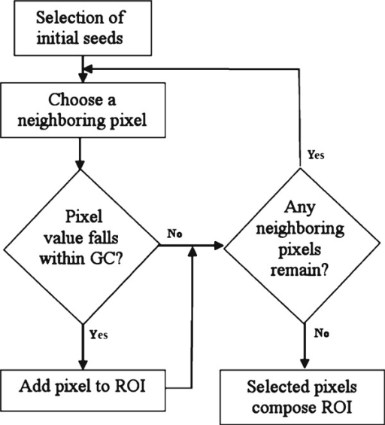

*3.4 Dice Similarity Coefficient*

Dice similarity coefficient or DSC is coefficient which measure similarity of two samples. In image processing it is used to measure the amount of overlapping area of the two images. It takes values between 0 and 1, where’s 0 signifies that two images are not overlapping at all and 1 signifies complete overlap of two images. DSC is an extension of volumetric similarity measurement (where volumes/areas of two images are compared to find similarity) and gives weightage to the positioning and configuration of the image along with the volume/area. Mathematically DSC for two image matrix X and Y can be given by,

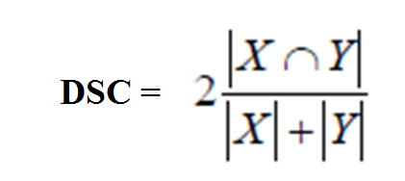

*2.5 Jaccard’s Similarity Coefficient*

Jaccard Similarity Coefficient or JSC is a coefficient which measures similarity of two samples. It is quiet similar to DSC except for small difference in its formula. SC for two image matrix X and Y can be given by,

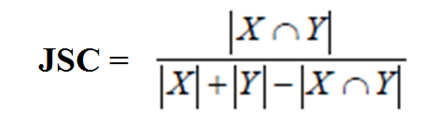

*2.6 Hausdorff’s Distance*

Hausdorff distance is a metric used to define the spatial distance between two sets of points.

The algorithm for this works as:

1)Consider a set of points A and a set of points B.  
h(A,B) being the distance between the maximum of set A and minimum of set B.  
2)Choose a point in Set A such as al and find the distance between this point and all the points in Set Bi (2<i<p)

3) Continue this for the other points in Set A.

According to the tolerance given, one boundary matches the other.

**CHAPTER 4**

**RESULT ANALYSIS**

*CT Images*

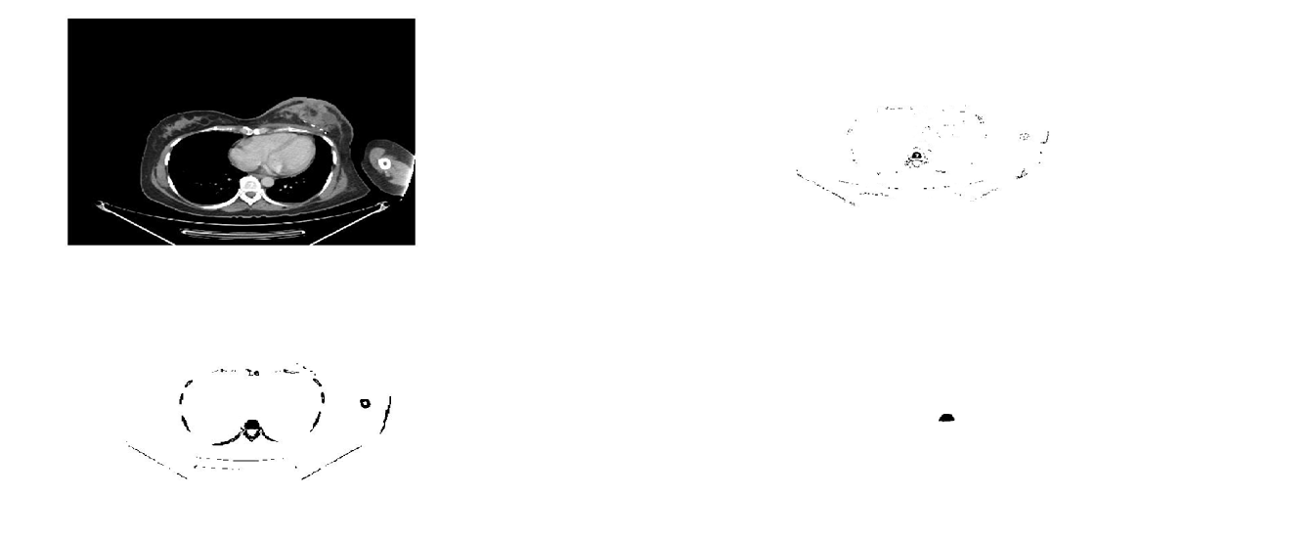

**Fig.4.1** *(Clockwise top left to bottom left)* *CT Image 1 of spinal Thoracic (cross section view) Source: Manipal Hospital Bangalore, Segmented image using Region growing, Segmented image using Thresholding, Ground truth which is manually segmented.*

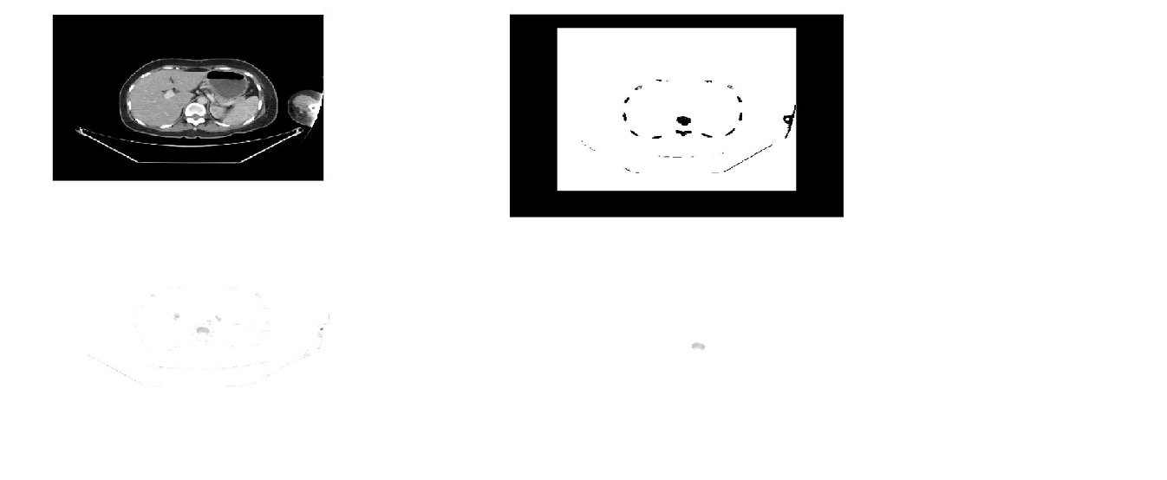

**Fig. 4.2** *(Clockwise top left to bottom left) CT Image 2 of spinal Lumbar (cross section view) Source: Manipal Hospital Bangalore, Segmented image using adaptive thresholding, Segmented image using Region growing, Ground truth which is manually segmented.*

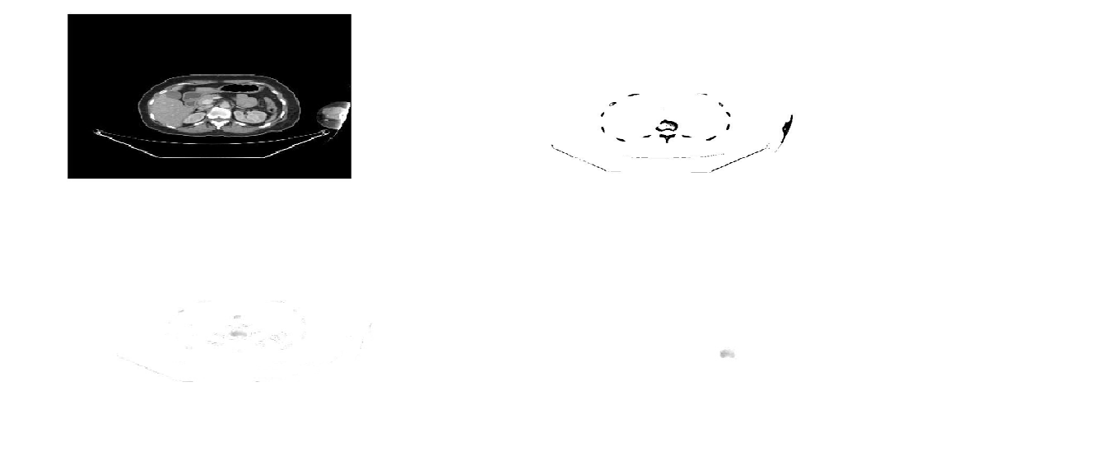

**Fig. 4.3** *(Clockwise top left to botton left) CT Image 3 of spinal Lumbar (cross section view) Source: Manipal Hospital Bangalore, Segmented image using adaptive thresholding, Segmented image using Region growing, Ground truth which is manually segmented.*

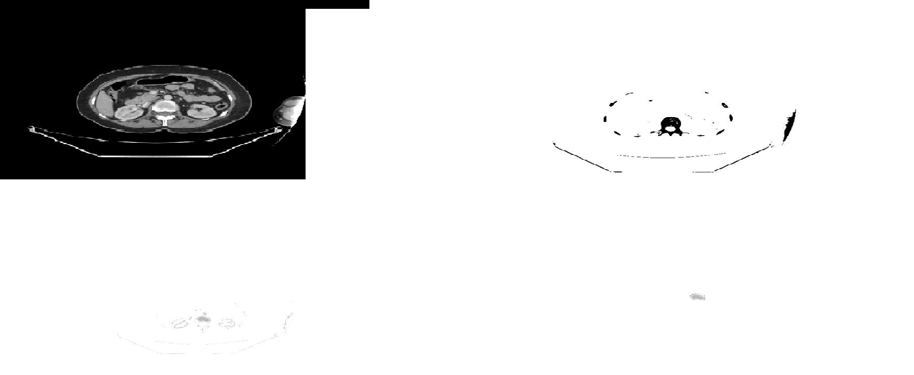

**Fig. 4.4** *(Clockwise top left to bottom left) CT Image 4 of spinal Lumbar (cross section view) Source: Manipal Hospital Bangalore, Segmentation using adaptive thresholding, Segmentation using region growing, Ground truth – manual segmentation.*

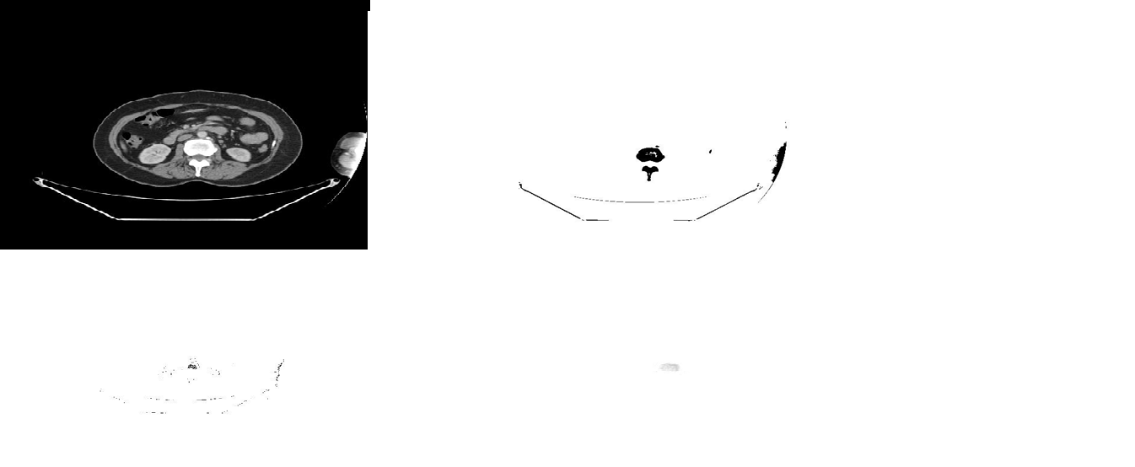

**Fig. 4.5** *(Clockwise top left to bottom left) CT Image 5 of spinal Lumbar (cross section view) Source: Manipal Hospital Bangalore, Segmentation using adaptive thresholding, Segmentation using region growing, Ground truth - manual segmentation.*

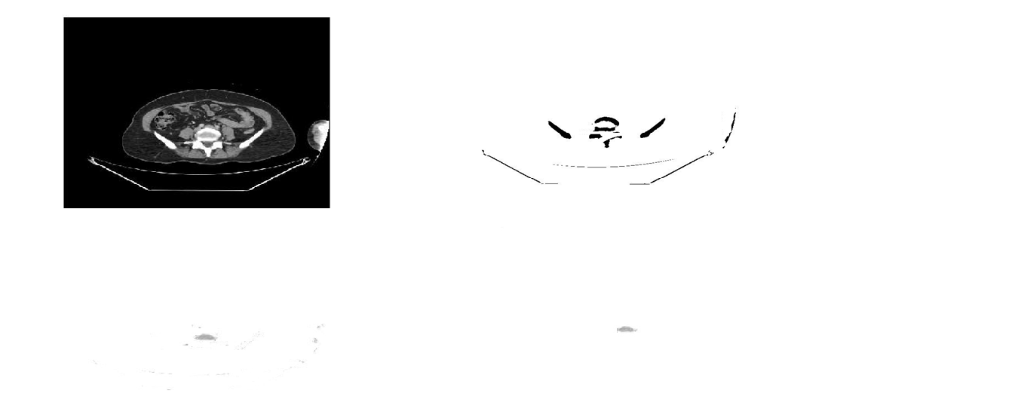

**Fig. 4.6** *( Clockwise top left to bottom left) CT Image 6 of spinal Lumbar (cross section view) Source: Manipal Hospital Bangalore, Segmentation using Adaptive thresholding, Segmentation using region growing,Ground truth – manual segmentation.*

*Similarity Coefficient Output:*

**Table 4.1** *Similarity Coefficients for Region Growing(CT images)*

|  |  |  |  |  |
| --- | --- | --- | --- | --- |
| S.No. | Type of image | Di-Similarity Coefficient | Jaccard Similarity Coefficient | Hausdorff Distance |
| 1 | CT Image1 | 0.9208 | 0.9205 | 203.72 |
| 2 | CT Image2 | 0.9519 | 0.9411 | 177.61 |
| 3 | CT Image3 | 0.9932 | 0.9930 | 10.73 |
| 4 | CT Image4 | 0.7331 | 0.7289 | 178.40 |
| 5 | CT Image5 | 0.6217 | 0.6145 | 228.07 |
| 6 | CT Image6 | 0.9895 | 0.9775 | 17.15 |

**Table 4.2** *Similarity Coefficients for Adaptive Thresholding(CT images)*

|  |  |  |  |  |
| --- | --- | --- | --- | --- |
| S.No. | Type of image | Di-Similarity Coefficient | Jaccard Similarity Coefficient | Hausdorff Distance |
| 1 | CT Image 1 | 0.8612 | 0.8599 | 313.40 |
| 2 | CT Image 2 | 0.8730 | 0.8672 | 201.34 |
| 3 | CT Image 3 | 0.8411 | 0.8322 | 155.21 |
| 4 | CT Image 4 | 0.8156 | 0.8110 | 164.89 |
| 5 | CT Image 5 | 0.5115 | 0.5104 | 225.12 |
| 6 | CT Image 6 | 0.8710 | 0.871 | 178.12 |

*Graphical Analysis:*

**Fig 4.7** *Graphical representation of the values obtained by Dice Similarity Coefficient*

**Fig 4.8** *Graphical respresentation of the values obtained by Hausdorff distance*

*Calculations:*

Mean DSC using Region Growing technique = 0.8683

Mean Hausdorff distance using region growing technique = 135.94

Mean DSC using Adaptive Thresholding technique= 0.7955

Mean Hausdorff distance using Adaptive Thresholding technique = 206.34

**Fig 4.9** *Comparing the graphs obtained by Mean DSC.*

*Conclusion*

Also, we can see region growing technique performed better in 5 out of 6 images as compared to adaptive tresholding technique.We can come to a conclusion that Region Growing technique performs better than Adaptive Thresholding technique for CT images.

**PET IMAGES**

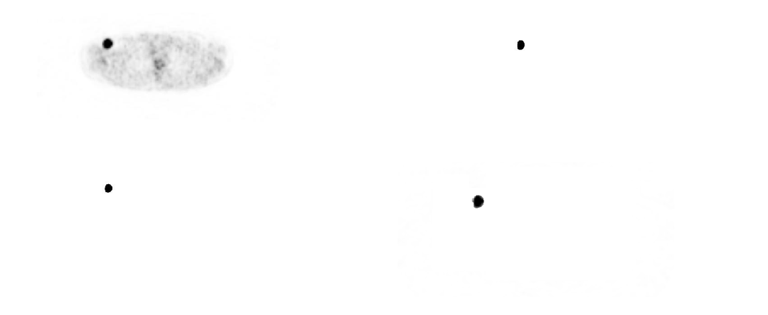

**Fig. 4.10** *(Clockwise from top left to bottom left) PET Image 1 of spinal Lumbar (cross section view) Source: Manipal Hospital Bangalore, Segmentation result using adaptive thresholding, Segmentation result using region growing technique, Ground truth – manual segmentation.*

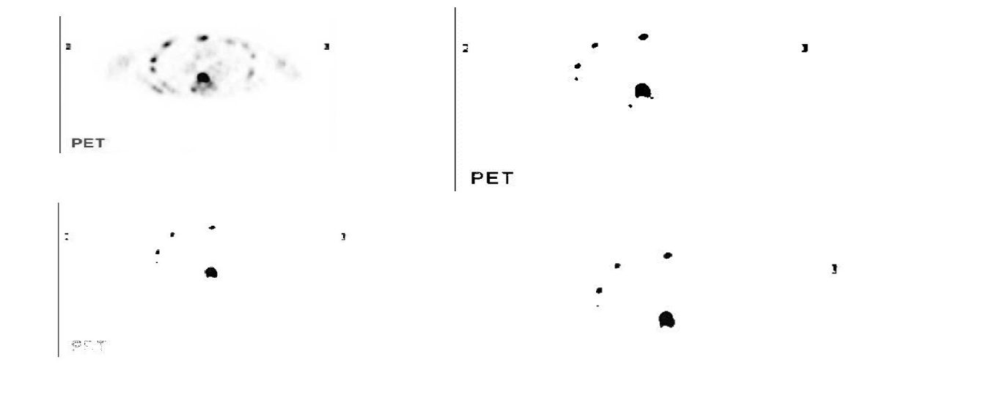

Fig. 4.11 *(Clockwise top left to bottom left)* *PET Image 2 of spinal Thoracic (cross section view)Source: Images given by DR.S.K.CHIRALA MBBS,MD,DRM,RSO,DNB,Nuclear Medicine Physician,Segmentation using adaptive thresholding technique, Segmentation using region growing,Ground truth – manual segmentation.*

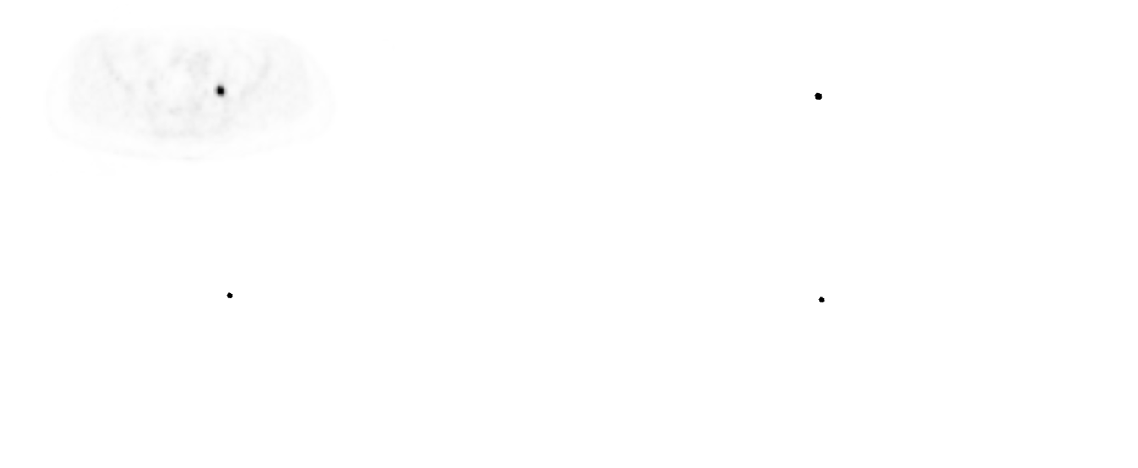

**Fig 4.12** *(Clockwise top left to bottom left)PET Image 3 of spinal lumbar (cross section view) Source: Manipal Hospital Bangalore,Segmentation using adaptive thresholding,Segmentation using region growing technique,Ground truth – manual segmentation.*

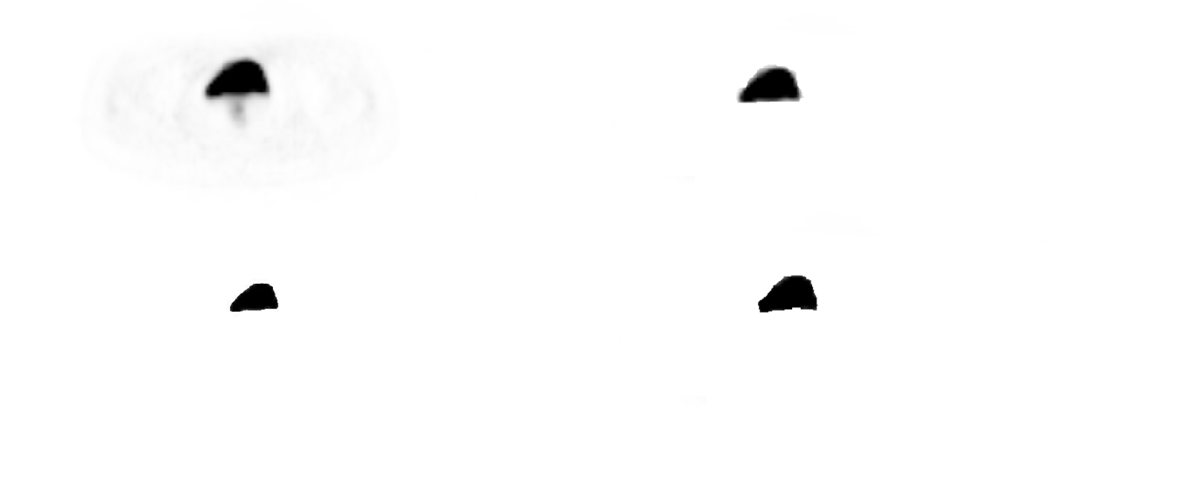

**Fig 4.13** *( Clockwise top left to bottom left) PET Image 4 of spinal lumbar (cross section view) Source: Manipal Hospital Bangalore, Segmentation using adaptive thresholding, Segmentation using region growing technique, Ground truth – manual segmentation.*

*Similarity Coefficients output:*

**Table 4.3** *Similarity Coefficients obtained by Region growing.*

|  |  |  |  |  |
| --- | --- | --- | --- | --- |
| S.No. | Type of image | Di-Similarity Coefficient | Jaccard Similarity Coefficient | Hausdorff Distance |
| 1 | PET Image1 | 0.9950 | 0.9944 | 112.54 |
| 2 | PET Image2 | 0.9965 | 0.9961 | 114.186 |
| 3 | PET Image3 | 0.8024 | 0.8021 | 145.12 |
| 4 | PET Image4 | 0.9101 | 0.9045 | 170.15 |

**Table 4.4** *Similarity Coefficients obtained by Adaptive Thresholding.*

|  |  |  |  |  |
| --- | --- | --- | --- | --- |
| S.No. | Type of image | Di-Similarity Coefficient | Jaccard Similarity Coefficient | Hausdorff Distance |
| 1 | PET – Image1 | 0.9952 | 0.9948 | 110.86 |
| 2 | PET – Image2 | 0.9987 | 0.9986 | 110.12 |
| 3 | PET – Image3 | 0.7984 | 0.7980 | 125.18 |
| 4 | PET – Image4 | 0.9206 | 0.9180 | 169.80 |

*Graphical Analysis:*

**Fig 4.14** *Graphical analysis of DSC, Comparing both techniques.*

**Fig 4.15** *Graphical analysis of Hausdorff Distance, Comparing both results*

*Calculations:*

Mean DSC using Region Growing technique = 0.9277

Mean Hausdorff distance using region growing technique = 135.50

Mean DSC using Adaptive Thresholding technique= 0.9282

Mean Hausdorff distance using Adaptive Thresholding technique = 128.99

Also, we can see adaptive thresholding technique performed better in 3 out of 4 images as compared to region growing technique.

**Fig 4.16** *Graphical analysis of Mean Hausdorff Distance.*

*Conclusion*

Adaptive thresholding technique performs better than Region growing technique for PET images.

.

**CHAPTER 5**

**CONCLUSION AND FUTURE SCOPE OF WORK**

*Conclusion*

In the case of CT images, we can come to a conclusion that Region Growing is a better technique. This can be explained as,

1. Region growing algorithm is more efficient for images with less noise as they use more than one parameter (intensities, texture, pixel connectivity) as compared to adaptive thresholding which use only intensities of pixel as a parameter to segment image.
2. Adaptive Thresholding doesn’t have any fixed analytic expression, these expressions depends upon the different cases, it might fail to fine tune with more complex images.

In the case of PET Images, We can conclude that Adaptive thresholding works better.This can be explained with following reasons:

PET images have more noise compared to CT images because of movement and varying concentration of radioactive tracer in the body. Region growing algorithm is more sensitive to noise as compared to Adaptive thresholding. This is because in region growing the neighbouring region could be falsely merged with the seed region because of low resolution of images, this effect is called leakage.

*Future Scope*

**REFERENCES**

***Journal / Conference Papers***

**Region Based Methods:**

[1] R. Adams, L.Bischof, Seeded region growing, IEEE Trans. Pattern Anal. Mach. Intell. 16(6)(1994)641–647.

[2] Z.Xu, Z.Gao, E.Hoffman, P.Saha, Tensor scale-based an isotropic region growing for segmentation of elongated biological structures, in: 20129th IEEE International Symposium on Biomedical Imaging(ISBI), 2012, pp.1032–1035.

[3] Z.Xu, U.Bagci, A.Kubler, B.Luna, S.Jain, W.R.Bishai, D.J.Mollura, Computer- aided detection and quantification of cavity tuberculosis from CT scans, Med. Phys.40 (11).

[4] Z.Xu, U.Bagci, B.Foster, D.J.Mollura, A hybrid multi-scale approach to automatic air way tree segmentation from CT scans, in: 2013 IEEE 10th International Symposium on Biomedical Imaging (ISBI), 2013, pp.1308–1311.

[5] H. Li, W.L. Thorstad, K.J.Biehl, R.Laforest, Y.Su, K.I.Shoghi, E.D.Donnelly, D.A. Low, W.Lu, A novel PET tumour delineation method based on adaptive region-growing and dual-frontactivecontours,Med.Phys.35(8)(2008) 3711–3721.

[6] H.Wechsler ,M.Kidode, A random walk procedure for texture discrimination, IEEE Trans.PatternAnal.Mach.Intell.PAMI1(3)(1979)272–280.

[7] S.Andrews, G.Hamarneh, A.Saad ,Fast random walker with priors using pre computation for interactive medical image segmentation, In Medical Image Computing and Computer-Assisted Intervention–MICCAI, 2010, pp. 9–16.

[8] L. Grady, Random walks for image segmentation, IEEE Trans. Pattern Anal. Mach. Intell.28 (11)(2006)1768–1783.

[9] Z.Xu, U.Bagci, B.Foster, A.Mansoor, D.J.Mollura, Spatiallyconstrained random walk approach for accurate estimation of air way wall surfaces, in: Medical Image Computing and Computer-Assisted Intervention MICCAI2013, Lecture Notes in Computer Science, vol.8150, Springer Berlin Heidelberg, 2013, pp.559–566.

**Thresholding based methods:**

[10] Geets X, Daisne J, Arcangeli S, et al. Inter-observer variability in the delineation of pharyngo-laryngeal tumor, parotid glands and cervical spinal cord: comparison between CT-scan and MRI. Radiother Oncol. 2005;77(1):25–31.

[11] Strauss MA and Conti PS. The application of PET in clinical oncology. J Nucl Med. 1991;32(4):623–48.

[12] Lecchi M, Fossati P, Elisei F, Orecchia R, Lucignani G. Current concepts on imaging in radiotherapy. Eur J Nucl Med Mol Imaging. 2008;35(4):821–37.

[13] Gould MK, Maclean CC, Kuschner WG, Rydzak CE, Owens DK. Accuracy of positron emission tomography for diagnosis of pulmonary nodules and mass lesions: a meta analysis. JAMA. 2001;285(7):914–24.

[14] Gambhir SS, Czernin J, Schwinner J, Silverman DH, Coleman RE, Phelps ME. A tabulated summary of the FDG PET literature. J Nucl Med. 2001;42(5 Suppl):1S–98S.

[15] Gondi V, Bradley K, Mehta M, et al. Impact of hybrid fluorodeoxyglucose positron-emission tomography/computed tomography on radiotherapy planning in esophageal and non-small-cell lung cancer. Int J Radiat Oncol Biol Phys. 2007;67(1):187–95.

[16] Stroom J, Blaauwgeers H, van Baardwijk A, et al. Feasibility of pathology-correlated lung imaging for accurate target definition of lung tumors. Int J Radiat Oncol Biol Phys. 2007;69(1):267–75.

[17] Aerts HJ, Bosmans G, van Baardwijk AA, et al. Stability of (18)F-deoxyglucose uptake locations within tumor during radiotherapy for NSCLC: a prospective study. Int J Radiat Oncol Biol Phys. 2008;71(5):1402–07.

[18] Killoran JH, Gerbaudo VH, Marmede M, Ionascu D, Park SJ, Berbeco R. Motion artifacts occurring at the lung/diaphragm interface using 4D CT attenuation correction of 4D PET scans. J App Clin Med Phys. 2011;12(4):261–74

**ANNEXURES**

*Adaptive Thresholding Function:*

function bw = adaptivethresh(im, fsize, t, filterType, thresholdMode)

% Set up default parameter values as needed

if nargin < 2

fsize = fix(length(im)/20);

end

if nargin < 3

t = 15;

end

if nargin < 4

filterType = 'gaussian';

end

if nargin < 5

thresholdMode = 'relative';

end

% Apply Gaussian or median smoothing

if strncmpi(filterType, 'gaussian', 3)

g = fspecial('gaussian', 6*fsize, fsize);

fim = filter2(g, im);

elseif strncmpi(filterType, 'median', 3)

fim = medfilt2(im, [fsize fsize], 'symmetric');

else

error('Filtertype must be ''gaussian'' or ''median'' ');

end

% Finally apply the threshold

if strncmpi(thresholdMode,'relative',3)

bw = im > fim*(1-t/100);

elseif strncmpi(thresholdMode,'fixed',3)

bw = im > fim-t;

else

error('mode must be ''relative'' or ''fixed'' ');

end

*Region growing function:*

function J=regiongrowing(I,x,y,reg_maxdist)

if(exist('reg_maxdist','var')==0), reg_maxdist=0.2; end

if(exist('y','var')==0), figure, imshow(I,[]); [y,x]=getpts; y=round(y(1)); x=round(x(1)); end

J = zeros(size(I)); %Output

Isizes = size(I); %Dimensions of input image

reg_mean = I(x,y); %The mean of the segmented region

reg_size = 1; %Number of pixels in region

% Free memory to store neighbours of the (segmented) region

neg_free = 10000; neg_pos=0;

neg_list = zeros(neg_free,3);

pixdist=0; % Distance of the region newest pixel to the regio mean

% Neighbor locations (footprint)

neigb=[-1 0; 1 0; 0 -1;0 1];

%Start regiogrowing until distance between regio and posible new pixels become

%higher than a certain treshold

while(pixdist<reg_maxdist&&reg_size<numel(I))

% Add new neighbors pixels

for j=1:4,

% Calculate the neighbour coordinate

xn = x +neigb(j,1); yn = y +neigb(j,2);

% Check if neighbour is inside or outside the image

ins=(xn>=1)&&(yn>=1)&&(xn<=Isizes(1))&&(yn<=Isizes(2));

% Add neighbor if inside and not already part of the segmented area

if(ins&&(J(xn,yn)==0))

neg_pos = neg_pos+1;

neg_list(neg_pos,:) = [xn yn I(xn,yn)]; J(xn,yn)=1;

end

end

%Add a new block of free memory

if(neg_pos+10>neg_free), neg_free=neg_free+10000; neg_list((neg_pos+1):neg_free,:)=0; end

%Add pixel with intensity nearest to the mean of the region, to the region

dist = abs(neg_list(1:neg_pos,3)-reg_mean);

[pixdist, index] = min(dist);

J(x,y)=2; reg_size=reg_size+1;

%Calculate the new mean of the region

reg_mean= (reg_mean*reg_size + neg_list(index,3))/(reg_size+1);

%Save the x and y coordinates of the pixel (for the neighbour add proccess)

x = neg_list(index,1); y = neg_list(index,2);

%Remove the pixel from the neighbour (check) list

neg_list(index,:)=neg_list(neg_pos,:); neg_pos=neg_pos-1;

end

% Return the segmented area as logical matrix

J=J>1;

*DSC Code*

clc;

I=imread('gt1.jpg');

J=imread('gt1result.jpg');

S=imresize(I, [100 100]);

D=imresize(J, [100 100]);

V=im2bw(S);

B=im2bw(D);

idx_img = find(V== 1);

idx_ref = find(B== 1);

idx_inter = find((V== 1) & (B== 1));

dist = 2*length(idx_inter)/(length(idx_ref)+length(idx_img));

*JSC Code*

function [jaccardIdx,jaccardDist] = jaccard_coefficient(img_Orig,img_Seg)

% Jaccard index and distance co-efficient of segmemted and ground truth

% image

% Usage: [index,distance(JC)] = jaccard_coefficient(Orig_Image,Seg_Image);

% Check for logical image

if ~islogical(img_Orig)

error('Image must be in logical format');

end

if ~islogical(img_Seg)

error('Image must be in logical format');

end

% Find the intersection of the two images

inter_image = img_Orig & img_Seg;

% Find the union of the two images

union_image = img_Orig | img_Seg;

jaccardIdx = sum(inter_image(:))/sum(union_image(:));

% Jaccard distance = 1 - jaccardindex;

jaccardDist = 1 - jaccardIdx;

*Hausdorff Distance*

function [hd D] = HausdorffDist(P,Q,lmf,dv)

% Calculates the Hausdorff Distance between P and Q

%

% hd = HausdorffDist(P,Q)

% [hd D] = HausdorffDist(P,Q)

% [hd D] = HausdorffDist(...,lmf)

% [hd D] = HausdorffDist(...,[],'visualize')

%

% Calculates the Hausdorff Distance, hd, between two sets of points, P and

% Q (which could be two trajectories). Sets P and Q must be matrices with

% an equal number of columns (dimensions), though not necessarily an equal

% number of rows (observations).

%

% The Directional Hausdorff Distance (dhd) is defined as:

% dhd(P,Q) = max p c P [ min q c Q [ ||p-q|| ] ].

% Intuitively dhd finds the point p from the set P that is farthest from

% any point in Q and measures the distance from p to its nearest neighbor

% in Q.

%

% The Hausdorff Distance is defined as max{dhd(P,Q),dhd(Q,P)}

%

% D is the matrix of distances where D(n,m) is the distance of the nth

% point in P from the mth point in Q.

%

% lmf: If the size of P and Q are very large, the matrix of distances

% between them, D, will be too large to store in memory. Therefore, the

% function will check your available memory and not build the D matrix if

% it will exceed your available memory and instead use a faster version of

% the code. If this occurs, D will be returned as the empty matrix. You may

% force the code to forgo the D matrix even for small P and Q by calling the

% function with the optional 3rd lmf variable set to 1. You may also force

% the function to return the D matrix by setting lmf to 0. lmf set to []

% allows the code to automatically choose which mode is appropriate.

%

% Including the 'vis' or 'visualize' option plots the input data of

% dimension 1, 2 or 3 if the small dataset algorithm is used.

%

% Performance Note: Including the lmf input increases the speed of the

% algorithm by avoiding the overhead associated with checking memory

% availability. For the lmf=0 case, this may represent a sizeable

% percentage of the entire run-time.

%

%

% %%% ZCD Oct 2009 %%%

% Edits ZCD: Added the matrix of distances as an output. Fixed bug that

% would cause an error if one of the sets was a single point. Removed

% excess calls to "size" and "length". - May 2010

% Edits ZCD: Allowed for comparisons of N-dimensions. - June 2010

% Edits ZCD: Added large matrix mode to avoid insufficient memory errors

% and a user input to control this mode. - April 2012

% Edits ZCD: Using bsxfun rather than repmat in large matrix mode to

% increase performance speeds. [update recommended by Roel H on MFX] -

% October 2012

% Edits ZCD: Added a plotting function for visualization - October 2012

%

sP = size(P); sQ = size(Q);

if ~(sP(2)==sQ(2))

error('Inputs P and Q must have the same number of columns')

end

if nargin > 2 && ~isempty(lmf)

% the user has specified the large matrix flag one way or the other

largeMat = lmf;

if ~(largeMat==1 || largeMat==0)

error('3rd ''lmf'' input must be 0 or 1')

end

else

largeMat = 0; % assume this is a small matrix until we check

% If the result is too large, we will not be able to build the matrix of

% differences, we must loop.

if sP(1)*sQ(1) > 2e6

% ok, the resulting matrix or P-to-Q distances will be really big, lets

% check if our memory can handle the space we'll need

memSpecs = memory; % load in memory specifications

varSpecs = whos('P','Q'); % load in variable memory specs

sf = 10; % build in a saftey factor of 10 so we don't run out of memory for sure

if prod([varSpecs.bytes]./[sP(2) sQ(2)]) > memSpecs.MaxPossibleArrayBytes/sf

largeMat = 1; % we have now concluded this is a large matrix situation

end

end

end

if largeMat

% we cannot save all distances, so loop through every point saving only

% those that are the best value so far

maxP = 0; % initialize our max value

% loop through all points in P looking for maxes

for p = 1:sP(1)

% calculate the minimum distance from points in P to Q

minP = min(sum( bsxfun(@minus,P(p,:),Q).^2, 2));

if minP>maxP

% we've discovered a new largest minimum for P

maxP = minP;

end

end

% repeat for points in Q

maxQ = 0;

for q = 1:sQ(1)

minQ = min(sum( bsxfun(@minus,Q(q,:),P).^2, 2));

if minQ>maxQ

maxQ = minQ;

end

end

hd = sqrt(max([maxP maxQ]));

D = [];

else

% we have enough memory to build the distance matrix, so use this code

% obtain all possible point comparisons

iP = repmat(1:sP(1),[1,sQ(1)])';

iQ = repmat(1:sQ(1),[sP(1),1]);

combos = [iP,iQ(:)];

% get distances for each point combination

cP=P(combos(:,1),:); cQ=Q(combos(:,2),:);

dists = sqrt(sum((cP - cQ).^2,2));

% Now create a matrix of distances where D(n,m) is the distance of the nth

% point in P from the mth point in Q. The maximum distance from any point

% in Q from P will be max(D,[],1) and the maximum distance from any point

% in P from Q will be max(D,[],2);

D = reshape(dists,sP(1),[]);

% Obtain the value of the point, p, in P with the largest minimum distance

% to any point in Q.

vp = max(min(D,[],2));

% Obtain the value of the point, q, in Q with the largets minimum distance

% to any point in P.

vq = max(min(D,[],1));

hd = max(vp,vq);

end

% --- visualization ---

if nargin==4 && any(strcmpi({'v','vis','visual','visualize','visualization'},dv))

if largeMat == 1 || sP(2)>3

warning('MATLAB:actionNotTaken',...

'Visualization failed because data sets were too large or data dimensionality > 3.')

return;

end

% visualize the data

figure

subplot(1,2,1)

hold on

axis equal

% need some data for plotting

[mp ixp] = min(D,[],2);

[mq ixq] = min(D,[],1);

[mp ixpp] = max(mp);

[mq ixqq] = max(mq);

[m ix] = max([mq mp]);

if ix==2

ixhd = [ixp(ixpp) ixpp];

xyf = [Q(ixhd(1),:); P(ixhd(2),:)];

else

ixhd = [ixqq ixq(ixqq)];

xyf = [Q(ixhd(1),:); P(ixhd(2),:)];

end

% -- plot data --

if sP(2) == 2

h(1) = plot(P(:,1),P(:,2),'bx','markersize',10,'linewidth',3);

h(2) = plot(Q(:,1),Q(:,2),'ro','markersize',8,'linewidth',2.5);

% draw all minimum distances from set P

Xp = [P(1:sP(1),1) Q(ixp,1)];

Yp = [P(1:sP(1),2) Q(ixp,2)];

plot(Xp',Yp','-b');

% draw all minimum distances from set Q

Xq = [P(ixq,1) Q(1:sQ(1),1)];

Yq = [P(ixq,2) Q(1:sQ(1),2)];

plot(Xq',Yq','-r');

% denote the hausdorff distance

h(3) = plot(xyf(:,1),xyf(:,2),'-ks','markersize',12,'linewidth',2);

uistack(fliplr(h),'top')

xlabel('Dim 1'); ylabel('Dim 2');

title(['Hausdorff Distance = ' num2str(m)])

legend(h,{'P','Q','Hausdorff Dist'},'location','best')

elseif sP(2) == 1

ofst = hd/2; % plotting offset

h(1) = plot(P(:,1),ones(1,sP(1)),'bx','markersize',10,'linewidth',3);

h(2) = plot(Q(:,1),ones(1,sQ(1))+ofst,'ro','markersize',8,'linewidth',2.5);

% draw all minimum distances from set P

Xp = [P(1:sP(1)) Q(ixp)];

Yp = [ones(sP(1),1) ones(sP(1),1)+ofst];

plot(Xp',Yp','-b');

% draw all minimum distances from set Q

Xq = [P(ixq) Q(1:sQ(1))];

Yq = [ones(sQ(1),1) ones(sQ(1),1)+ofst];

plot(Xq',Yq','-r');

% denote the hausdorff distance

h(3) = plot(xyf(:,1),[1+ofst;1],'-ks','markersize',12,'linewidth',2);

uistack(fliplr(h),'top')

xlabel('Dim 1'); ylabel('visualization offset');

set(gca,'ytick',[])

title(['Hausdorff Distance = ' num2str(m)])

legend(h,{'P','Q','Hausdorff Dist'},'location','best')

elseif sP(2) == 3

h(1) = plot3(P(:,1),P(:,2),P(:,3),'bx','markersize',10,'linewidth',3);

h(2) = plot3(Q(:,1),Q(:,2),Q(:,3),'ro','markersize',8,'linewidth',2.5);

% draw all minimum distances from set P

Xp = [P(1:sP(1),1) Q(ixp,1)];

Yp = [P(1:sP(1),2) Q(ixp,2)];

Zp = [P(1:sP(1),3) Q(ixp,3)];

plot3(Xp',Yp',Zp','-b');

% draw all minimum distances from set Q

Xq = [P(ixq,1) Q(1:sQ(1),1)];

Yq = [P(ixq,2) Q(1:sQ(1),2)];

Zq = [P(ixq,3) Q(1:sQ(1),3)];

plot3(Xq',Yq',Zq','-r');

% denote the hausdorff distance

h(3) = plot3(xyf(:,1),xyf(:,2),xyf(:,3),'-ks','markersize',12,'linewidth',2);

uistack(fliplr(h),'top')

xlabel('Dim 1'); ylabel('Dim 2'); zlabel('Dim 3');

title(['Hausdorff Distance = ' num2str(m)])

legend(h,{'P','Q','Hausdorff Dist'},'location','best')

end

subplot(1,2,2)

% add offset because pcolor ignores final rows and columns

[X Y] = meshgrid(1:(sQ(1)+1),1:(sP(1)+1));

hpc = pcolor(X-0.5,Y-0.5,[[D; D(end,:)] [D(:,end); 0]]);

set(hpc,'edgealpha',0.25)

xlabel('ordered points in Q (o)')

ylabel('ordered points in P (x)')

title({'Distance (color) between points in P and Q';...

'Hausdorff distance outlined in white'})

colorbar('location','SouthOutside')

hold on

% bug: does not draw when hd is the very last point

rectangle('position',[ixhd(1)-0.5 ixhd(2)-0.5 1 1],...

'edgecolor','w','linewidth',2);

end

PROJECT DETAILS

|  |  |  |  |
| --- | --- | --- | --- |
| *Student Details* | | | |
| **Student Name** | **Sree Pranavi Kanduri** | | |
| Register Number | 120907138 | Section / Roll No | D/10 |
| Email Address | pranaveekanduri@gmail.com | Phone No (M) | 9886435882 |
| **Student Name** | **Parth Sehgal** | | |
| Register Number | 120907626 | Section / Roll No | C/50 |
| Email Address | Parthsehgal94@yahoo.com | Phone No (M) | 9886429190 |
|  | | | |
| *Project Details* | | | |
| **Project Title** | **SEGMENTATION OF BONE LESIONS ON PET/CT IMAGES USING ADAPTIVE THRESHOLDING AND REGION GROWING TECHNIQUES: A COMPARITIVE STUDY.** | | |
| Project Duration | 4 months | Date of reporting | 11th Jan 2016 |
|  |  | | |
| *Organization Details* | | | |
| **Organization Name** | **Manipal Institute of Technology** | | |
| Full postal address with pin code | Madhavnagar, Manipal, Udipi district, 576104 | | |
| Website address | Manipal.edu | | |
|  |  | | |
| *Supervisor Details* | | | |
| **Supervisor Name** | **Suhas M.V.** | | |
| Designation | Assistant Professor | | |
| Full contact address with pin code |  | | |
| Email address |  | Phone No (M) |  |
|  |  | | |
| *Internal Guide Details* | | | |
| **Faculty Name** | **Suhas M.V.** | | |
| Full contact address with pin code | Dept of E & C Engg, Manipal Institute of Technology, Manipal – 576 104 (Karnataka State), INDIA | | |
| Email address | Suhas.mv@manipal.edu | | |